CURRICULUM VITAE
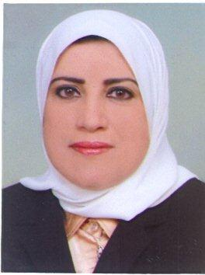

Personal Information

Name: Dr. Muna Al Musawi
Nationality: Bahraini
Address: House 1395, Road 3427, Block 934, Riffa, Bahrain
Contact Number: (+973) 39622424, (+973) 17622424
E-mail Address: mmosawi@health.gov.bh
Dr.almusawi@gmail.com
Date of Birth: Dec, 8 1959
Nationality: Bahraini
Marital Status: married

Career Objective

My goal is to prevent, detect and control the spread of diseases through international transport

Education
1997 I graduated from the Royal College of Physicians in Ireland and Royal College of Surgeons in Ireland with a Diploma in Management.
January 1992 I graduated from The Royal College of Physicians in Ireland and Royal College of Surgeons in Ireland in with a Diploma in Psychology.
October 1984 I join the Family Practice Residency Program in and graduated in October 1987 from the American University of Beirut.
December 1982. I graduated from Faculty of Medicine of Ain Shams University in Egypt with the honor degree of M.B., B.Ch in
I worked as

- Primary Care Physician from 1987 until now.
- Doctor in charge of Jidhafs Health Center from 1988 to 1999.
- Manager for acute respiratory disease in Bahrain since 1993.
- Ultrasound doctor for pregnant women attending the antenatal clinic since 1994.
- Manager of the Expanded Program on Immunization from 18.8.1994 to 2009.
- Ante-natal doctor at Jidhafs Health Center from 1987 to 1999.
- Doing premarital and periodic women screening.
- MCH Supervisor from 1987 to 1999.
- Psychologist since 1992.
- Chief of the Diseases Control Section from 2004 to April 2010.
- Country National Focal point for the International Health Regulations since 2007 until now.
- Public Health Consultant for implementation of the International Health Regulations since May 2010.

Current job status

- Consultant Family Physician.
- Country National Focal Point for the International Health Regulations.
- Public Health Consultant for Implementation of the International Health Regulations.
- Senior Psychologist.

