CURRICULUM VITAE
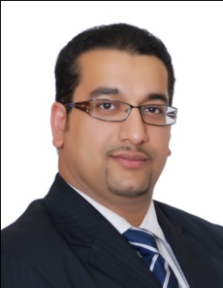

Personal Information

Name: Ammar Rajab
Nationality: Bahraini
Address: Flat 11 House 473, Road 5417, Block 254, Galali, Bahrain
Contact Number: (+973) 39861644, (+973) 17200971
E-mail Address: abinrajab@mofa.gov.bh
ammarbinrajab@gmail.com
Date of Birth: Jan, 5 1981
Nationality: Bahraini
Marital Status: married

Career Objective

Building relationships and frameworks that protect the rights and interests of the Kingdom of Bahrain and its people in the international arena. Striving To consolidate peace, security, stability, justice, and development and to develop bilateral and multilateral relations, based on the principle of good neighbourliness, and on international agreements and conventions, in order to implement the Kingdom’s strategy.

Education
2002 Obtain the DELF (Diplôme d'études en Langue Française ) as a Diploma in French from Alliance Française of Bahrain
2003 I graduated from the University of Bahrain with an Associated Diploma in French Language.

2003 Obtain the DALF C1 (Diplôme Approfondi de Langue Française) as a Second Diploma in French from Alliance Française of Bahrain.
2010 - Now I'm currently studying at the AMA International University of Bahrain majoring in International Studies.
I worked as

- Diplomatic attaché in the Organization Directorate at the Ministry Of Foreign Affairs (2003 - 2005).
- Diplomat in the Permanent Mission of the Kingdom of Bahrain to the United Nations Office in Geneva (2005 - 2010).

Current job status

- Second Secretary in the Organization Directorate at the Ministry Of Foreign Affairs.

